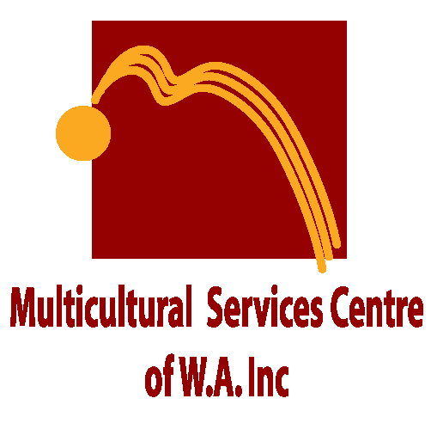
Multicultural Legal Centre

4 View Street, North Perth WA 6006
T: 08 9328 1544, F: 08 9277 7638, E: legal@mscwa.com.au
W: www.mscwa.com.au

Objectives

The Multicultural Legal Centre aims to provide culturally and linguistically diverse communities (CaLD) equal access to the justice system.
The Centre’s main objective is to provide legal advice and representation in areas such as:
- Personal injury
- Workers’ compensation
- Motor vehicle accidents
- Criminal injuries compensation
- Employment law
- Wills, probate and power of attorney
- Violence restraining orders
- Property – dividing fences, neighbourhood disputes

Our Legal Team
Mr Leo Gatica-Lara, Principal Solicitor, has extensive experience in supporting the multicultural community. With a background in social work and a lawyer for 15 years, Leo has particular expertise in the area of personal injury and assists at Legal Aid in the Civil Law section.
Mr Paulose Doss, Solicitor, was admitted to the Supreme Court of Western Australia as a legal practitioner in 2016. Paulose will be under the supervision of Mr Gatica-Lara.
In addition to the MLC team, the Centre has access to private lawyers working on a pro bono (free) basis.
Communication
Language should not be an impediment to equal access to the justice system.
Mr Leo Gatica-Lara speaks Spanish and Italian while Mr Paulose Doss speaks Tamil, Malayalam, Hindi, Telugu and Kannada.
Professional interpreting services will be used to cover other languages.
Fees
The initial 30-minute consultation and legal advice is free of charge. If representation in a court or tribunal is required, the aim of the Centre is to make this service accessible and affordable by keeping legal costs as low as possible.
Funding will be sought through Legal Aid WA’s Social Inclusion Program and relevant organisations wherever possible to minimise costs payable by clients.
Business Hours and Appointments
Monday to Fridays 9.00am to 5.00pm and Wednesday s 11to 6 pm. Appointments can be made in person, or via phone, fax or email.

