~~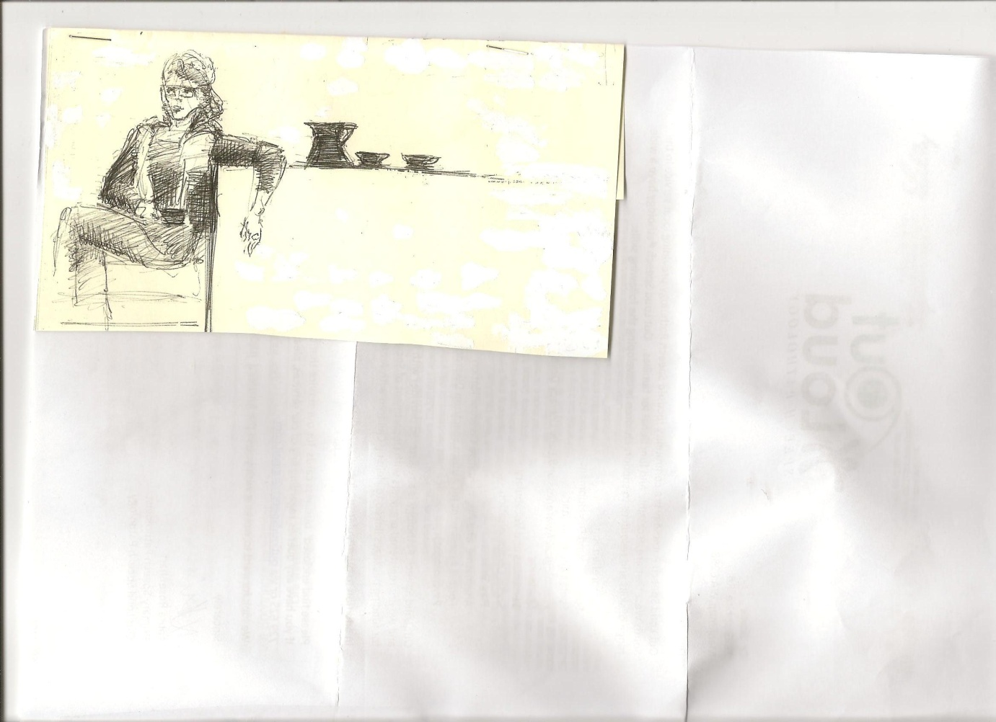~~

**Welcome Bytes readers,**

We’ve made it to Spring and when this time of the year comes around we always have more than spring fever buzzing in the air, we have the footy finals fever with people in high excitement about which team will be flying the winner’s flag.

Will your team take out the flag in 2017? It all comes down to that big day, with Grand Finals being held on September 9th at Imperials Oval, so get your team colours on and get down there supporting your team.

Good luck everyone!

We always welcome your ideas at [manjicafebytes@g.mail.com](mailto:manjicafebytes@g.mail.com) and copies are also online at http://www.manjimupcrc.net.au

**Issue 40 September 2017**

**Who are we? The Bytes Team who bring you this publication are:**

**Rae Starr, Manjimup CRC rae@manjimup.org.au**

**Liz Coley & Kathy Hill**

**Yarn Spinners** [**manjicafebytes@gmail.com**](mailto:manjicafebytes@gmail.com)

**Design: Tracey Bingham**

**Manjimup CRC: Kayla Williams and Emma Lee Mayer**

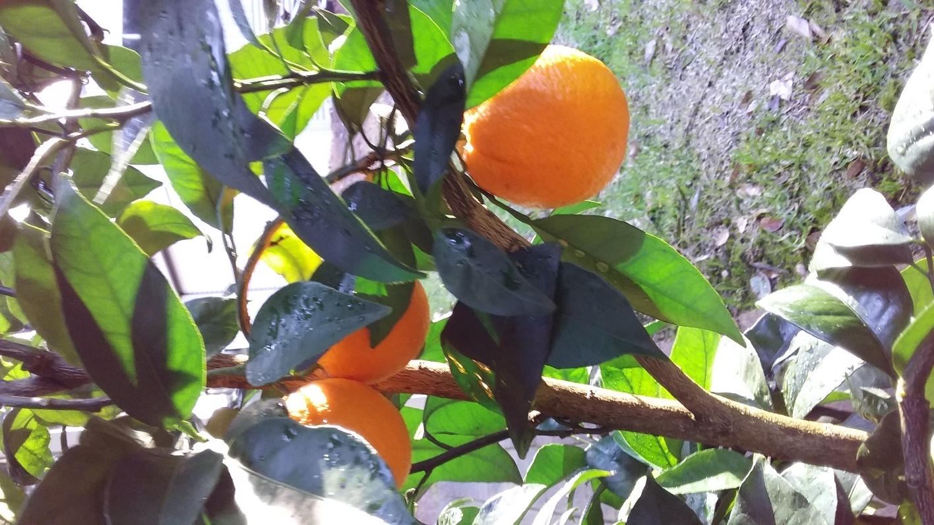

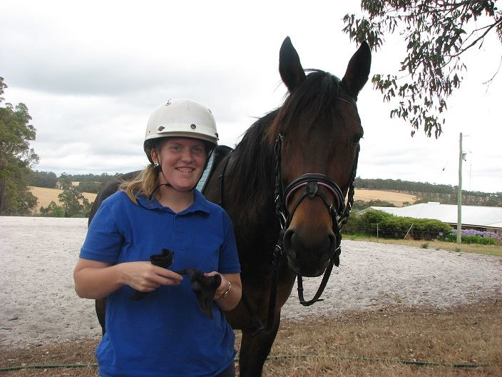

**SAYING FOR THE MONTH**

***“The time to begin most things is ten years ago.” – Mignon McLaughlin (1913-1983)***

**CHAT SUBJECT**

***If you could live anywhere in the world, where would you choose to live?***

Artist : John Duncan

**FREE**

Manji Cafe Bytes

**Foster Carers desperately needed**

There are over 200 children in Out of Home care in the Great Southern region. Wanslea Foster Care is seeking families across the region who are able to take on the care of children in need. Vulnerable children are exposed to sometimes shocking traumatic events and put at risk in their family home. Imagine being a child exposed to domestic violence, abuse, drug and alcohol or neglected.

Wanslea is a community based organisation striving to do the best for children in our local area, children who have been removed from their family due to high safety concern. We are trying to find people to become foster carers and provide a safe nurturing home for children in our community.

**Can you be that one person to make a difference in a child’s life?**

Many children that come into care think they are at fault. Many children have missed out on developmental milestones, missed many days of school, miss out on opportunities that most kids have.

*The little boy had never had a roast dinner, been to the movies or taught how to swim. He had no idea about the game hide and seek. He just knew how to hide.*

**Do you have time to listen and offer your time to making a child’s life better?**

Wanslea Foster Carers report that the rewards of fostering outweigh the challenges. Fostering is about making a difference to each individual child that you have contact with.

*I provide emergency care, I see the child arrive at the front door with eyes to the floor. Not wanting anyone to see them. We say hello, welcome them in, and acknowledge that this must be really scary for them.*

Our ultimate goal is for the child to be reunited with their family. We work alongside the child, family, and other agencies in planning for the future for the child. Achieving stability for children is critical for them to form relationships and attachment. Connection to culture is vital as they grow, these connections help children to understand where they come from and to develop a sense of belonging and identity.

*Little Miss 5 is with us long term, she sees her family every week, including aunts, uncles and nanna. Nanna is teaching her Noongar language and her family traditions. Now Miss 5 is teaching us.*

**Can you provide a safe and nurturing home?**

Foster carers can choose the level of commitment they are able to make taking into account their family situation. Wanslea is seeking all types of carers to provide emergency, temporary, permanent and short stay placements for children. Wanslea offers 24 hour support and staff work alongside carers and children through their journey.

*Foster carers don’t have to be superheros, people from all walks of life can open their hearts and home to make a difference. I work full time and have a 8 year old boy, I provide care one weekend a month for two little girls to give the other carers a break. They have just started calling me Aunty B ☺*

*The support we have received from Wanslea has been 10 out of 10 and exceeded our expectations.*

*Fostering can be difficult but the most immensely rewarding and an incredible experience for the whole family*

*We are not here to fix the children we are here to help them thrive in life.*

If you live in the Great Southern and are interested in learning more about fostering a child, please visit [www.fosternow.com.au](http://www.fosternow.com.au) or call 9843 0077.



**John Austin, Quinninup. Major Exhibition**

Local photographer records decades of change

*John Austin: Survey II 1994-2017* will open at Bunbury Regional Art Galleries (BRAG) on Friday 15 September from 6pm.

This exhibition is part of an ongoing series of major retrospective exhibitions at BRAG by some of the most respected senior artists of the South West. *Survey II* is the second major exhibition of Austin’s work following on from *John Austin: Photography 1970-1993* which was exhibited at Lawrence Wilson Art Gallery in 1993.

“Practitioners such as John Austin, who have worked so consistently to develop their practice and their creative voice play a unique role in the cultural ecosystem of our state,” says BRAG director Julian Bowron. “The retrospective is a chance for us to celebrate and recognise this sustained effort, and share the resulting cultural contribution with diverse audiences.” In the interests of documenting this extraordinary contribution, the exhibition is accompanied by a full catalogue, featuring essays by Dr Diana McGirr and Sarah Drummond.

The timeframe for Austin’s retrospective begins with the photographer’s move to Quinninup, a small forest town in the South West of WA, and also marks the start of his engagement with anti-logging protests in this area. Documentation of these protests – and the destruction of the South West forests are an integral part of the photographer’s oeuvre.

These images – many of which are deeply jarring, sit alongside other, more restful bodies of work, such as the *Littoral and Limnal* series of intertidal zones, sites which are described by the artist as “owned by both the sea and the land.” The female nude is also a strong feature of Austin’s work, and often these strong women are featured within the forest environment, standing at odds with the destruction present in the *Forest Witness: Threnody and Conflict* series.

*Survey II* also features a collection of the artists snapshots, together described as *Eclection* where the photographer speaks of waiting for the story to emerge. As Sarah Drummond suggests in her essay, these snapshots document a part of the artist’s life.

Together, the works in this exhibition present a sense of documentation on a greater scale. As artistic objects, their balance and beauty draw the viewer in and present a unique take on the familiar iconography of the South West. The value of these work also extend beyond the artistic to the cultural. Presented together their stylistic cohesion present a clear and personal cultural record of the environment and cultural milleau in which they exist, from the perspective of a photographer who has carefully tuned his work and sensibilities.

All of the images are shot on film, and processed in Austin’s Quinninup darkroom studio, Austin is known for working exclusively with fine silver-gelatine black and white prints, normally from large format cameras, and this sustained engagement and ongoing refinement of the technical processes of his craft results in a cohesive oeuvre, which, although spanning a broad range of subjects, present a clear vision through the eye of the photographer.

John Austin’s career in photography spans over a 45 year period, during which time he has held over eleven solo exhibitions and been featured in multiple groups shows. His work is part of numerous collections including the National Portrait Gallery, Art Gallery of Western Australia, Curtin University of Technology and Bunbury Regional Art Galleries.

Exhibition Opening: Friday 15 September, 6pm

Artist talk: Saturday 16 September, 2pm

Exhibition Runs: 16 September – 26 November 2017

BRAG is open 10am – 4pm daily and entry is free

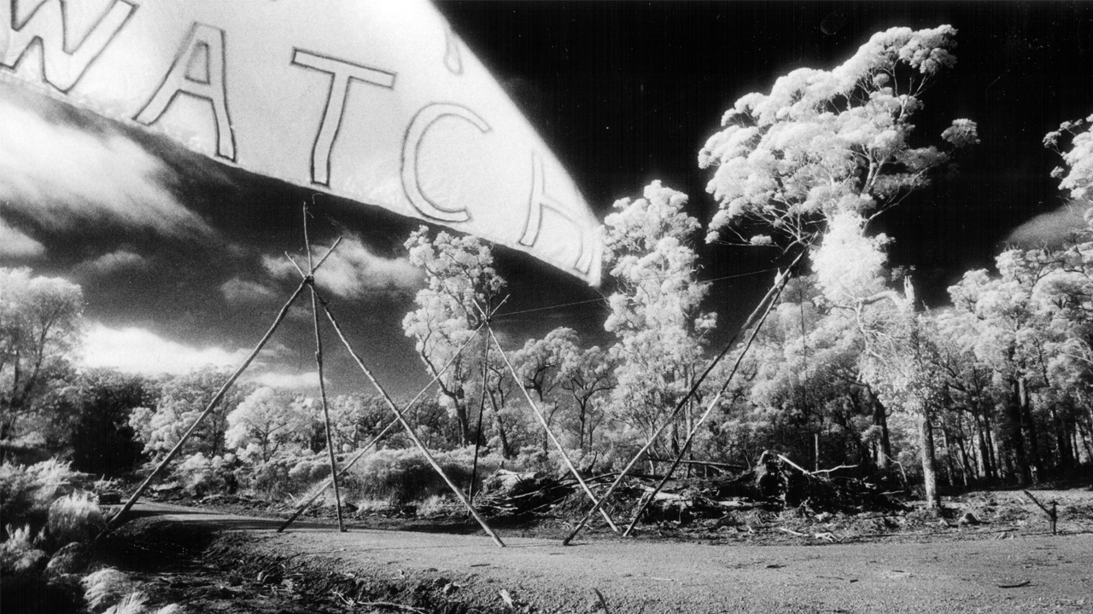

**

**Thumbs Up**

When the winter rain was lashing down with the winds rattling all around, most of us were sheltered inside, hoping that our homes would stand up to the elements. What would the SES volunteers be doing while the storms are on? They’d be listening out for anyone who needed emergency assistance. Our sincere thanks go out to these generous volunteers, the community certainly appreciates your efforts.

**ORANGES**

Oranges ripening on the tree are a welcome sight at this time of year, their bright orange glow set amongst glossy dark green leaves is a sharp contrast to the grey skies of winter and spring. And once plucked from the tree their distinctive aroma brings thoughts of summer and lazy days ahead.

Sweet oranges are the fruit of *citrus x sinensis* and are a hybrid between pomelo and mandarin. They have been around for a long time, as early as 314BC according to Chinese literature. Oranges are believed to have their origins in southern China and north-eastern India. The Moors introduced the orange to Andalusia in Spain, where large scale cultivation began in the 10th century, sweet oranges were introduced to the Mediterranean area by Italian and Portuguese merchants in the late 15th century. They were considered a luxury and wealthy people grew them in orangeries. As oranges are high in vitamin C Spanish, Portuguese and Dutch sailors planted them along trade routes to prevent scurvy. They are now one of the most cultivated fruit trees in the world and sweet oranges account for approximately 70% of citrus production.

Navel oranges were introduced to Australia in 1824 and in Florida in 1835. In 1870 twelve cuttings of the original tree were sent to California where they thrived and became known as the Washington Navel. As the fruit was seedless this cultivar rapidly spread to other countries and is still popular in Australia today. Other popular varieties include Valencia, Hamlin and Salustiana,

If you want to grow your own oranges, it is worth waiting until the temperature warms up to about 14deg C. Before planting soak the tree roots in a bucket of water and then plant into a prepared hole or large pot making sure the soil level is the same as the original. Give them a dose of citrus fertiliser and a couple of handfuls of chicken manure now and again. Don’t overwater, if the leaves feel firm and are shiny and cool, your plant is happy, it will thrive over spring and summer and reward you next winter with an abundant supply of fresh juicy fruit.

Oranges are an excellent source of vitamin C and are high in dietary fibre. They also contain the B vitamins including vitamin B1 as well as vitamin A, calcium, copper and potassium.

**Liz’s Kitchen Rules**

**ORANGE & ALMOND SELF SAUCING PUDDING**

Ingredients: 1 cup SR flour, ½ cup caster sugar, ½ cup almond meal, 1 tablesp grated orange rind, ½ cup milk, 1 egg, 50g melted butter, 1 tablesp cornflour, ½ cup extra caster sugar, 1½ cups fresh orange juice.

Method: Preheat oven to 180C. Brush a 1.5L ovenproof dish with melted butter. Place on a tray lined with baking paper. Sift flour into a large bowl, stir in sugar, almond meal and orange rind. Whisk the milk, egg and melted butter in a jug until combined. Stir into the flour mixture until smooth, pour into prepared dish and level the surface. Combine cornflour and extra sugar in a bowl and sprinkle over the pudding mixture, place orange juice in a small saucepan and bring just to the boil, pour over the back of a spoon over the pudding mix. Bake for 45 -50 mins until golden brown. Stand for 5 minutes, dust with icing sugar and serve with custard or ice cream.

Perfect comfort food for a cold spring day!

Add to shopping list

Turn this recipe into a shopping list you can print, email or view on your mobile. It's free! Powered by Whisk.com

View list

Add to shopping list

Turn this recipe into a shopping list you can print, email or view on your mobile. It's free! Powered by Whisk.com

**FAULTY TOWERS**

Saturday evening 12th August was cold, wet and windy, but it did not dampen the enthusiasm of the Fawlty Towers fans chatting over pre-dinner drinks at Tall Timbers on Giblett Street.

None of us knew quite what to expect, the doors were closed and we peered in trying to get a glimpse of the crew. Just after 7pm Basil Fawlty appeared, called out our names and we were ushered inside to beautifully set tables, there wasn’t a spare chair left by the time we were all seated.

It didn’t take long for chaos to ensue, Manuel flung warm bread rolls around the room eagerly caught by hungry diners, and didn’t wait for the soup to be served but sprinkled parsley straight on to the table. The chef lost his false teeth, half the set was located by one of the ladies tucking in to her soup at our table, humblest apologies from Basil as Manuel entertained us by leaping onto one of the tables and giving us a rousing rendition of Viva Espana.

We were all in fits of laughter and it wasn’t long before Basil asked Manuel to put a $50 bet on a likely horse stressing that under no account was he to tell Sybil. Eventually the inevitable happened, the horse won and Sybil wanted to know where the cash came from. Manuel brought the house down with his “I know nothing”.

There was someone in the room who happened to be German which gave Basil the opportunity to entertain us with his “Don’t mention the war” etc. We had a fire drill and diners at an adjacent table were ejected outside and the door firmly closed behind them by Mr Fawlty. They did make their way back in again.

Manuel dived under our table searching for his pet Siberian Hamster, it looked mighty like a rat, just glad it was a fake one, or the table would have cleared!

A lot of the fun and games are improvised on the night, Faulty Towers The Dining Experience is an affectionate homage to Fawlty Towers the TV series written by John Cleese and Connie Booth. The show began in Brisbane in 1997 and has travelled around the world spreading much hilarity among the audience, ten teams of cast now tour the world virtually non-stop, our cast featured Karen Hamilton (Sybil), Rob Langston (Basil) and Andy Foreman (Manuel). Now in its 20th year it is still going strong and will tour Europe, Scandinavia, Singapore and the Caribbean and Australia in 2017.

Thanks to Tall Timbers for bringing the show to Manjimup, I’ll definitely be booking if it comes this way again, if you missed this 2 ½ hours of helpless laughter and spontaneous chaos I can highly recommend that you buy yourself a ticket next time and join the fun.

**QUIZ NIGHT FOR MICHELLE**

Local Manjimup girl, Michelle Aiken is waiting for October to roll around as she trains for the Riding for the Disabled Association National Championships which will be held at the Werribee Park National Equestrian Centre, Victoria on the 4th to 6th October 2017.

Michelle has been competing for about 9 years and she and her horse Jaffa have been training for 1-2 hours on as many days as she can manage. She has won a number of previous awards and is a worthy representative for our state.

As you can imagine there are a lot of competition expenses which include her uniform, accommodation, travel and equine costs etc. The family are busy planning fundraiser events to help Michelle out and are holding a Quiz Night at St Joseph’s Parish Centre on the 30th September. Tickets are $10 for tables of eight, main prizes are dinner vouchers at Manjimup Motor Inn, valued at $240, there are door prizes and loads of raffle prizes, $2 per ticket. Doors open at 6pm for a 6.45pm start, door sales will be available on the night, tickets can be purchased at Manjimup Florist 97711728 or Debra 0428771397 (after hours).

Michelle has also been selected to represent Western Australia at the Special Olympics in Adelaide, South Australia from 16th to 20th April 2018, another one to look forward to and we wish you all success Michelle!

**LET’S GO WALKING**

As spring arrives with the promise of warmer days ahead it’s time to get out there and enjoy some of that fresh air and sunshine.

And what more enjoyable way than to take some of the walks around town, the Shire of Manjimup have a guide to walking and cycling paths in Manjimup, some you may be familiar with and others you may like to explore.

The King Jarrah Walk is a 3.5km (one way) path beginning at Manjimup Timber & Heritage Park and on to Perup Road, it wends its way past the Golf Course and through farmland, ending at the magnificent King Jarrah. The tree stands 45m high and is estimated to be about 500 years old. There is an interesting story about how it survived the earlier timber cutters. Back in 1910 Bert Blakers heard that the tree was due to be felled the next day. Recognising it as special, he went into the forest and marked it “to be protected”. He then cycled to Bridgetown to speak to his boss, Mr Brockman, who agreed with the decision and that is why old KJ is still there for us to marvel at today. There is a 650m sealed trail at the reserve which has toilet, picnic and barbecue facilities.

Deanmill Heritage Trail is a 6km (one way) walk which follows the old rail line and forms part of the Munda Biddi Trail. Start this one at Rose Street and onto the old line between Lock and Plunkett Streets. The path will take you through farmland and stands of natural bush ending at Deanmill Oval. The rail line was constructed between Deanmill and Manjimup in 1912, Deanmill became the site of the Number One State Saw mill and provided sleepers for the construction of the Transcontinental Railway Line. The settlement was named after Mr Alfred Dean, the Mill Construction Engineer, who was its first manager. The hauling of logs from the bush to the mill by locomotives ceased in 1955, the line was closed in 1966 and the tramway dismantled in the 1980’s. It is a moderately flat, well defined trail and there should be plenty of wildflowers to admire along the way.

Some shorter town walks include West Manjimup, 2.8km, a circuit along Rutherford and Leman Streets which includes Manjimup Primary and High schools, Kearnan College, the Recreation Grounds and the Aqua Centre. East Manjimup 2km, starting at Manjin Park loop around Hospital Avenue, O’Connor Street and back along Young Street, this takes you past the East Manjimup Primary School and the bush reserve. South Manjimup 3.2km is a reasonably flat walk along Ipsen, Chopping and Giblett Streets with a slight rise in Somerville Street, some semi-rural views. Anunaka loops around SW Highway, Perup Road, Karri and Blechynden Streets, some great views towards King Jarrah from the top of Karri Street.

If you are after a real work out why not try the Manji Loop (12km), start at the Timber & Heritage Park, Karri Street, the notorious hills on Blackbutt Drive, Doust, O’Connor and Brain Streets, cross over the highway to Chopping Street, along Somerville, Duffield, Lintott, Finch and finally Johnson Street back to the park where you can head to the café for a coffee and a well-earned rest. This walk will give you some lovely views taking in some of the beautiful scenery at the edge of town.

A walk to bear in mind will be the development of the Linear Recreation Park, this is scheduled to be completed in March 1918 with the removal of the disused rail line which runs through the centre of town. This walk will link the Timber & Heritage Park and Manjin Park, effectively connecting the South West highway and town centre, it is hoped to direct visitors towards retail, entertainment and recreation venues thereby supporting local business and tourism. It will also allow additional and relocated path connections and is eventually proposed to be extended to Jardee and Palgarup town sites.

Remember to take water, put on sunscreen and wear a hat, comfortable clothing and sturdy shoes, happy walking!

***Quinninup Market Day 1st October 2017***

*The Annual Quinninup Market Day is a celebration of our community and our beautiful landscape, it is also our main annual fundraising event that sustains community activities. The event this year is particularly important to Quinninup following the devastating fire and subsequent loss of the historic Quinninup Tavern.*

*The 2017 Market Day on 1st October and runs from 10am to 3pm. The Free event will be brimming with activities for all. You can find the ever –popular Market Day at the Quinninup Community Centre and oval on Wheatley Coast Road, Quinninup.*

*Market Day features include over 50 market stalls selling a variety of regional goods and produce, local foods, wine tastings and sales. New to 2017 is the Quinninup Markets Food Hall, comprising a ‘tea room’ featuring Sylvia’s legendary Devonshire teas, barbeque items, garden and fruit salads, cakes and takeaway curries. Live music will entertain you whilst enjoying your tasty lunch. Wood Turning and engraving demonstrations and sales, Arts and Crafts, History and environmental displays are also an integral part of this year’s event.*

*For younger visitors there are free children’s activities, including a community artist-led workshop making Tie-dye tee shirts, the Radrock Climbing Wall, Laser Tag, Scout Rope Bridge Building, Bouncy Castle and Face Painting, fun for kids of all ages.*

*The Quinninup Market Day has been described as ‘The best community event in the Region’, also comments from younger visitors include ‘Quinni rocks!’ There is no doubt that the day will include something for everyone.*

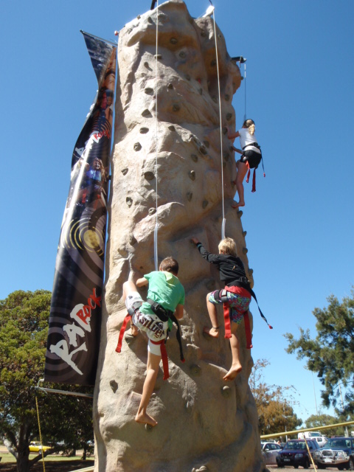

**THAT FOOT TAPPING BLUEGRASS IS RETURNING!**

Listen out for the sounds of music floating in the air on the Queen’s Birthday long weekend September 22nd to 24th,

Courtesy of the Warren Arts Council, Manjimup will once again be host to 40 or so musicians from here, there and everywhere.

Top bluegrass musos Ian Simpson, banjo, Adam Gare, mandolin, both from Perth, Donal Baylor, fiddle, coming from Canberra and Tony O’Rourke, guitar, from Melbourne, will be in town to run workshops, jams and give a public concert on Friday 22nd Sept.

At the Friday night acoustic concert at the Manjimup Repertory Theatre you will hear an exciting variety of music styles as each musician takes his turn to lead a tune or song. Tickets $30, adults, $15 school aged children ($25 adult early bird).

Once again there will be a Bush Dance so on Saturday night you can join in the fun on the dance floor and rattle those rafters at the Manjimup Town Hall.  You can make it a real family affair, as entry is free for school children and adult tickets only $20 ($15 early bird).

Tickets for both events are available now at the Manjimup Visitor Centre. For more details about the weekend www.manjimupbluegrass.com

What is very much needed is volunteers to help serve food and drinks to the 40 or so musicians on Saturday and Sunday, morning and afternoon, so anyone out there who would like to be involved, and witness the joy of making music, please email Kathy Hill at  Café  Bytes,  [manjicafebytes@gmail.com](javascript:_e(%7B%7D,'cvml','manjicafebytes@gmail.com');) or info@manjimupbluegrass.com